

Official Newsletter of Single Square Dancers, U.S.A. - Joe B. Ellis, Founder November 2017 Issue

48th Dance-A-Rama
“Race To Square Up”
August 30 – September 2, 2018
The Westin Hotel, Indianapolis, IN

Welcome to the 48th National Singles Dance-a-Rama, to be held at the beautiful Westin Hotel in downtown Indianapolis, IN. As usual, it will be over the Labor Day Weekend, August 30th through September 2, 2018.

The Westin Hotel has 667 rooms, so we will try to fill them all with our great staff of callers, cuers, and line dance leaders. We have some of the old favorites and some are new “rookies.”

Tom Miller, Mike Hogen, Tim Tyl, and Tom Davis are the favorites. Travis Cook is the “rookie” as this will be his first national event; although, he has been calling for 12 years. Cathy & Fred Fisher and Phyllis & Doug Burdette both have been to a couple of Dance-A-Ramas. They too will have a “rookie” cuer by the name of Pauline Angress. Tom Miller is from PA, Mike Hogan is from NE, Tim Tyl is from TX, Tom Davis is from OH, and Travis Cook is from KY. The cuers come from AR, OH and AL. To handle the line/country western dancing, we have Doug & Donna Riley from VA.

The hotel is now accepting reservations at the price of $109.00 per night, one to four people per room. They are also providing the wooden dance floors for our dancing pleasure. We will have up to 25,000 square foot of floor, which will be divided into five halls. We will also have a badge vendor and a square dance shop, so you can buy that new good looking outfit, or you can get your personal nametag from Suzie-Q.

This dance is a cooperative between the SSDUSA Board and some dancers from the IN area. This was agreed upon at the WASCA festival in March of 2016. John Cook is the co-chairman from IN, and they will handle the ground work in that area. They will also assist with hospitality and registration. The SSDUSA Board will be represented by Ron Holland as the co-chairman. We have been working together for some time, and things are working out very well. At this time, we have mailed or handed out approximately 3,200 flyers. If you wish some flyers for your club or area, just email John at squardanc@aol.com or Ron at hollardr@charter.net.

We also have five different tours planned this year, the highlight of two of them are the wine tasting tour and a trip to the Indianapolis 500 Racetrack and Museum. The museum has several race cars of different racing venues, you might even get to go to the starting line and “kiss the bricks.” The Mystery Tour on Sunday morning is still a mystery, but we guarantee that it will be FUN.

As our numbers at Little Rock were low, we are asking for your help to not only attend, but bring someone with you. If we can double that number, think of the fun we could have. Five hundred is a number that we have not seen in several years. Our T-shirts and Polo shirts are green this year. We did not order as many this year, so you need to get your shirt before they are sold out.

Ron Holland – Co-Chairman & John Cook – Co-Chairman

BRENDA GRIFFIN President – 2017/2018

SINGLE SQUARE DANCERS, USA OFFICERS

President
BRENDA GRIFFIN
arkidancer@yahoo.com
103 Indian Springs Drive
Bryant, AR 72022
501-416-5366

Vice President

VACANT

Secretary,
Intercom Editor
VIRGINIA M. FROMEL
vfromel51@comcast.net
6400 85th Place
New Carrollton, MD 20784
301-552-1576

Treasurer
SUSAN LEE
rflxsue@aol.com
819 Pleasantview Dr
Des Moines, IA 50315-2262
515-244-3247

Immediate Past President
ARTS
Promotions Director
ARBELL THOMPSON
arbellthompson@aol.com
19375 Cypress Ridge Ter, #406
Lansdowne, VA 20176
703-729-2109

YellowRock Scholarship
VELMA DOYLE
velmadoyle@sbcglobal.net
3938 Crestfield Drive
Groveport, OH 43125
614-837-6974

Atlantic East:
HELEN JACOBSON
helen.jacobsonRN@gmail.com
10 Rickland Drive
Randolph, NJ 07869
973-442-0836

South East:
Archives, Historian,
Sergeant-at-Arms,
Nominations,
ByLaws/Parliamentarian,
Outfit & Merchandise
RON HOLLAND
hollandr@charter.net
280 Walnut Grove Road
Lebanon, TN 37090-9110
615-268-3797

Message From Your President

N. Central East
FRED MOORE
velmadoyle@sbcglobal.net
3938 Crestfield Drive
Groveport, OH 43125
614-837-6974

North West:
HELEN CLARK
helen0151@gmail.com
26173 S Milk Creek Circle
Mulino, OR 97042
503-502-2041

North Cent. West:

VACANT

South West:

VACANT

South Central:

VACANT

North East:
NANCY MIRABAL
nancylmirabal@yahoo.com
112 Falmouth Street
Rochester, NY 14615-1902
585-738-3431

48th DAR Co-Chairs
RON HOLLAND
hollandr@charter.net
280 Walnut Grove Road
Lebanon, TN 37090-9110
615-268-3797
And
JOHN COOK
squardanc@aol.com
346 East Center Street
Dunkirk, IN 47336
765-215-5924

Intercom Publisher
& Membership
AILENE PICHECO
apicheco@att.net
345 Hula Circle,
Merritt Island, FL 32952
321-652-0680

Room-mate Locator
LAURIE STEWARD
lkstewa@hotmail.com
6373 Falcon Way
Warsaw, MN 55087
507-685-4476

Web Master
VACANT

I would like to first thank those that have put their faith in me to be President of Single Square Dancers USA (SSDUSA) for this next year of 2017/2018. I intend to serve in the best capacity I can and to hopefully help move this organization forward in a positive and pleasing way to all its members and potential members.

I live in Arkansas and have been square dancing since 1988, round dancing since 1995, and a member of SSDUSA since 2005 when I was asked to chair a Dance-A-Rama in Arkansas in 2007. I have served as a Regional Director, Treasurer (3 years), Dance Chairman twice (2007 & 2017), Vice President twice, a very short term of President in 2007/2008 and now President in 2017/2018. I have held several offices in local clubs and the Arkansas State Federation to the tune of Treasurer, Vice President, and President multiple times and the Asst. Vice Chairman of Rounds for the 63rd National Square Dance Convention held in Arkansas in 2014. My tenure in SSDUSA and square dancing has provided me the opportunity to attend many Dance-A-Ramas and several National Square Dance Conventions all across this country and afforded me the pleasure of meeting the most wonderful and fun loving people all over this great nation. It has been one of the most rewarding activities I have ever had the pleasure of being a part of. Hopefully, my past experiences serving as a board member or officer in several different square dance organizations as well as my love for the activity will give me the necessary tools and knowledge to be a President that you expect and want.

I know everyone is busy with family, jobs, lives, etc. However, the SSDUSA board has several vacancies that need to be filled. If you are looking for a place to serve then one of these vacant positions could be the place for you. Please give Velma Doyle (Vice President) or me a call, and we can give you more details on what is available, how to get started, and what duties the position may entail. We understand the cost of travel is expensive to attend meetings but with all the technology available to us now, you do not have to travel to the meetings to participate. You can join any meeting by phone or skype and still be at home. In order to continue to sustain and grow this organization, we need your help.

If you were unable to attend the Dance-A-Rama held in Arkansas this year, you missed what I truly believe was another great dance. The callers and cuers were superb as usual. The hotel was most gracious and hopefully a great time was had by all. As the dance chairman for this year’s dance, I would like to thank all those volunteers that helped to make everything go smooth. I would also like to thank all the dancers that were able to make this year’s dance because without dancers there would be no dance. There were several dancers that were unable to attend because of the hurricanes, and we continue to wish them a speedy and successful recover from whatever devastation they may have incurred. The Dance-A-Rama for 2018 will be back in Indianapolis, Indiana. Ron Holland and John Cook have already started working diligently to make this year’s dance the best ever. Show them your support by registering for the dance early and making your hotel reservations ASAP. Pre-registering helps the committee plan a better dance and getting your hotel reservations early guarantees you a room at the dance venue.

If you have any questions you can call me at 501-416-5366 or email me at arkidancer@yahoo.com Remember…..get out there and dance. It’s not only good for the body, but the soul as well. . I can’t wait to see you in Indianapolis.

Brenda Griffin, President -- 501-416-5366

TRESURER’S COMMENTS

Did you know that SSDUSA has a facebook page -- just search for Single Square Dancers USA.
You can find information of the next Dance-A-Rama plus find information about other single friendly events.

Susan Lee, Treasurer

FRANK NORRIS YELLOWROCK SCHOLARSHIPS AVAILABLE

Single Square Dancers U.S.A. is pleased to announce that four new callers – Katherine Lawson of Roanoke, VA; Beth & Stan Neidecker of Spring Hill, KS; and Jennifer Troy of Taylor, MI have been selected as the 2017 winners of the Frank Norris Yellowrock Scholarship. Katherine Lawson is a young caller who is starting college at Liberty University in Lynchburg, VA this fall. She started to develop her caller skills under the tutelage of her local club, the Star City Promenaders, and caller, Paul Booze. She has attended the Appalachian Caller’s School in Berkeley Springs, WV and the Grand Square, Inc. (GSI) school which was held prior to the 66th National Square Dance Convention in Cincinnati, OH. She hopes to help grow the popularity of square dance by offering square dance lessons for college students, and says she is excited to do all she can to make sure that square dance continues and keeps impacting lives, like it has hers. Beth and Stan Neidecker are affiliated with the Docey Dandies club. They have just begun calling, doing a few tips at a couple of local dances. This past spring they taught a mainstream class of seven students. They both attended the Heart of America Caller School, and are now looking for opportunities to call wherever they can. Jennifer Troy is a third generation square dancer who loves both dancing and calling. She has attended two GSI caller schools and has called at National and State Conventions, party night dances, full dances and over 40 lessons. She plans to start lessons designed for families, in hopes that this will help square dancing survive for many years to come.

The money in this scholarship fund was generated over the years by the sales of Yellowrock Directories. Since SSDUSA no longer publishes the Yellowrock, this source of funding the scholarships has been eliminated, but we are able to continue to award scholarships due to the generous insurance policy left to SSDUSA by Frank Norris who was our Yellowrock Scholarship Chairperson for many years until his death in the spring of 2007. The purpose of the fund is to help new callers and cuers with the expenses associated with getting started in the profession. It is open to any callers or cuers who have three years or less experience. It is open to adults and also to youth ages 12 through 18 with parental consent. Anyone interested in applying needs to submit a demo CD, along with an application, to Velma Doyle, Yellowrock Scholarship Chairperson, 3938 Crestfield Dr, Groveport, OH 43125. If you need a Yellowrock Scholarship application, download a copy from the SSDUSA Website: www.ssdusa.org, or contact me. The deadline for receipt of the completed packet is August 1. Scholarships are awarded each year at the annual Dance-A-Rama festival.

Velma Doyle, Yellowrock Scholarship Chairperson

NEWS FROM ATLANTIC EAST REGION

November Intercom - Atlantic East

Several clubs in NJ, Delaware and PA have been having Benefit Dances for Tom MIller. Thousands of dollars have been raised for his medical care, and we wish Tom a thorough recovery!

In other news, some solo friendly clubs have been implementing Singles Rotation systems at their dances. A solo dancer put his/her name on a list with sign in. That name gets matched up with a rotation of other names. It would be interesting to hear how other clubs do rotation systems.

Busy Bees Square Dance Club in Brooklawn NJ has been using a rotation system to insure that all solo dancers are out on the floor. They have a Plus/ROunds dance every Wednesday night from 7:30 - 10:00 pm. See busybssquares.weebly.com.

Rutgers Promenaders have moved to North Brunswick NJ, They still have their solo friendly, family friendly dances (MS/Rds) on first and third Sunday afternoons. Their big Toys for Tots dance is Sunday, Dec. 3. Callers are Betsy Gotta and Dan Koft. Cuers are Roy Gotta and Kathy Koft. See rutgerspromenaders.org.

Single Funtimers in Katonah NY is collaborating with the Friendly Squares Dance club on some Saturdays, alternating MS/Pl from 7:30-10 pm. Their Dinner and Student level MS/Pl dance is Dec. 2. Call Maryjane or Robert at 551-206-7905.
Do you dance Advanced? Solo dancers are always welcome at the Motivators in Hawthorne NJ on first and third Sunday evenings. A computer rotation system is used for solos and couples. C1 program is danced from 6:30 - 7:30, then A2 is dances from 7:30 - 9:30. Hawthorne is in northern NJ but is also accessible to the NY Hudson valley and Albany areas. Contact. cmimigirl@aol.com.

(PA) The Lehigh Valley B&Bs Square Dance Club is hosting their annual Presidents' Day Weekend (Plus/Rounds) at the Cacapon State Park Lodge in Berkeley Springs West Virginia. Callers are Tom Miller and Bill Harrison, with Tim Eum cueing. The weekend package includes two nights of lodging and meals, dances, workshops, and afterparties. Walk-ins and one day visitors also welcome. Email for info: mauger@ptd.net.

Helen Jacobson, Regional Director

NEWS FROM SOUTH EAST REGION

I will be attending several festivals in our district in coming months, and if anyone is interested in helping support the upcoming DARA, please see me at any of these dances or contact me at hollandr@charter.net. If anyone needs any flyers for the convention; please contact me, and they will be sent to you immediately.

Ron Holland, Regional Director

NEWS FROM NORTH CENTRAL EAST REGION

If you did not attend the Single Square Dancers USA Dance-A-Rama festival in North Little Rock, AR this Labor Day Weekend, you missed out on a lot of fun! The callers and cuers were outstanding! The tours were great! Velma and I especially enjoyed the Hot Springs Tour with the Belle Riverboat Cruise. The Mystery Tour was also a lot of fun. Mike Hogan called and we danced at the Big Dam Bridge, the Arkansas Capitol, the Clinton Presidential Library and the River Market.

Bucks & Does Singles celebrated 42 years as a singles club at their Anniversary Dance on Sept 22 with Jason Raleigh calling and Sue Powell cueing. We were delighted to have Nev and Bev McLachlan, a caller and cuer couple from Australia join us for the evening, with Nev calling a tip and Bev cueing one set of rounds. There are several solo friendly special dances coming up in Central Ohio. Bucks & Does Singles’ Annual Yellow Rock Special is on Sunday, November 12 from 1:30 to 4:30 PM, at Eastpointe Christian Church, 745 N Waggoner Rd, Blacklick, OH 43004, with caller Jack Pladdys and cuer Phyllis Burdette. The Central Ohio Corporation of Dance Clubs is holding its Toys for Tots Special Dance on Dec 10 from 2 to 5 PM with assorted callers from the Central Ohio Callers Association. Orbiting Squares is holding its New Year’s Eve Dance on Dec 31 starting with a potluck meal at 7:30 PM. Caller: Tom Strickland and Cuer: Chuck Berry. Both dances will be held at the Gahanna Community Congregational Church, 470 Havens Corners Rd, Gahanna, OH. If you plan to be in Central Ohio, you can find information about these and other dances at www.CentralOhioSquareDancing.com. If you know of other solo friendly dances in our region, please call me at 614-837-6974 or email Velma Doyle at velmadoyle@sbcglobal.net so we can add your information to my North Central East Region Intercom articles.

We are excited that the 48th Dance-A-Rama festival next Labor Day weekend will be in Indianapolis, IN. Be sure to mark your calendars and start making plans to attend this fun festival!
I am always on the lookout for more State Representatives to cover different areas in the North Central East Region. Primarily it involves distributing Dance-A-Rama flyers and getting the word out about our wonderful organization. If you live in Illinois, Indiana, Kentucky, Michigan, Ohio, or West Virginia and would like to become a SSDUSA State or Local Representative, please contact me at 614-837-6974.
See you in a square!

Fred Moore, Regional Director

HELP WANTED!!!!!!!!!!!!!!! VICE PRESIDENT, WEBMASTER AND
NORTH CENTRAL WEST, SOUTH CENTRAL & SOUTH WEST REGIONAL DIRECTORS
A cry goes out – WE NEED YOU!! WE WANT YOU TO JOIN US!! Why don’t you call us and volunteer for one of the following vacancies. We need a Vice President and a Webmaster for the Upcoming Board 2017/18. Additionally, we have three regions that need representatives. SSDUSA has divided up the U.S. into regions and have assigned representatives to provide a voice for singles throughout the U.S. We currently have three Regions that have no representation. Won’t you consider representing your regional area if you live in any of the states in the following Regions? The Regions that have no representation currently on our Board are:
North Central West Region – consists of the following states: Iowa, Minnesota, Nebraska, North Dakota, South Dakota, Wisconsin, Upper Michigan and Canada
South Central Region – consists of the following states: Arkansas, Kansas, Louisiana, Missouri, Oklahoma and Texas
South West Region: consists of the following states: Arizona, California, Colorado, New Mexico, Nevada, Utah and Hawaii
Wouldn’t you like to volunteer for one of these positions? Please contact one of the following to find out more information:
Brenda Griffin, President, 501-416-5366 email: arkidancer@yahoo.com
Arbell Thompson, Past-President, 703-303-5031 (cell) email: arrbellthompson@aol.com

FROM THE ROOMMATE LOCATOR

If you have decided to attend Dance-A-Rama and would like a roommate, book your room. Really hard to get a roommate when you can't offer a room. Then again, really easy to cancel a room reservation if you and your roommate have room reservations. I will begin taking roommate requests June 1, 2018, and will start working on them around the middle of July. Keep in mind that I will be gone the last part of June for two weeks so you may not hear from me but I will acknowledge emails whenever I get close to internet.

If anyone is planning on the National Convention the end of June I will take requests beginning in May. Remember, the closer to the event, the more requests I receive. Sometimes it gets a little dicey but only one time (a smoker) that I wasn't able to make things work. Wait, two times, the other was two men for Nationals and neither one wanted to give up their room. Figure that.

See you at Dance-A-Rama 2018.

Laurie -- Lkstewa@hotmail.com, 507-685-4476 H or 507-210-6507 C

Here’s a message from Mike Wilson Christensen,
Jeanne Henery, a square dancer from Norfolk, Nebraska, passed away very suddenly on June 12, 2017. She contributed a lot to square dancing. She helped with the Single Wheelers Memorial Weekend in Norfolk. She attended many Dance-A-Ramas, national conventions, and was a faithful square dancer.
Mary (Wilson) Christensen

Help Wanted – Webmaster

After many years as the SSDUSA webmaster, it’s time for me to step down. I no longer have the time and my web software is outdated. SSDUSA needs someone familiar with the latest website technology, or someone who can use the ready-made sites found on WIX, GoDaddy, or many other sites. I’ll try to give you the technical details of how the current site is constructed.

Currently SSDUSA.Org is hosted by 1and1.com. Basically we are renting a webserver from them and paying approx. $215 a year (about $52 a quarter). For that price we actually get 2 or 3 websites, although we are only using one. I had set up SSDUSA.net as a backup at one time.

With our 1and1.com package we also get numerous subdomains, which is what we’ve been using for Dance-A-Rama sites – like dar2017.ssdusa.org. We can also create over 500 email addresses, and have a lot of disk storage space. There is also an email package that we can use for emailing out newsletters or other information.

Our current webpage was created using Dreamweaver CS4. It is written in a mix of HTML and CSS code. 1and1.com has the capability of creating our webpages with their site creator tools. This is basically a plug and play site and anyone with a little graphic experience could create a site. I have not played with Site Creator, so I don’t know how easy it is, but it should be similar to WIX, GoDaddy, and other site creator tools.

The advantage of writing a website in HTML and/or CSS is that they perform better in search engines, like Google and Yahoo. The advantage of keeping our current 1and1.com account is the large number of subdomains and email addresses we have. It is also a very secure site with a lot of great features.

If we cannot find someone familiar with HTML/CSS coding, then I suggest finding someone with experience creating sites on other platforms using their site creator tools. Then they can create a new SSDUSA.Org on our 1and1 platform using that site creator tool.

I will be glad to work with anyone that wants to take this job on. Just contact me via email at dave@daveswebplace.net or naturephotos@cox.net. You can also call me at 757 642-6722.

Dave Hinde, Web Master

THE DANCE PROGRAM IS PROVIDED FOR YOUR ADVANCE PLANNING
Types of Dancing (all 3 days): Mainstream, Plus, DBD, Advanced, Rounds, & Lines
Square Dance Attire Required For All Evening Sessions.
48th DANCE-A-RAMA DANCE PROGRAM

Thursday, August 30, 2018
2:00 - 6:00 pm Registration Open

7:30 - 10:30 pm Trail In Dance - Mainstream
With Rounds and
Announced Plus
(Pay at the door $10.00)
Saturday, September 1, 2018
9:00am Registration Opens
10:00 am Dancing Begins
2:00 pm SSDUSA Members General Meeting
7:00 – 10 pm SSDUSA Grand March “Red,
White, & Blue" & Evening Dancing
10:30 pm - After Party
1:00 am

Friday, August 31, 2018
9:00 am Registration Opens
10: 00 a m Bid Presentations
10:30 a m Dancing Begins
6:45 - 10:00 Parade of States & Evening Dancing
10:30 – 12:30 a m After Party

Sunday, September 2, 2018
9:00 am – 1 pm Dangle Dance Tour
10: 00 am Dancing Begins
7:00 - 10:00 pm Grand Finale & Trail Out Dance in Ballroom

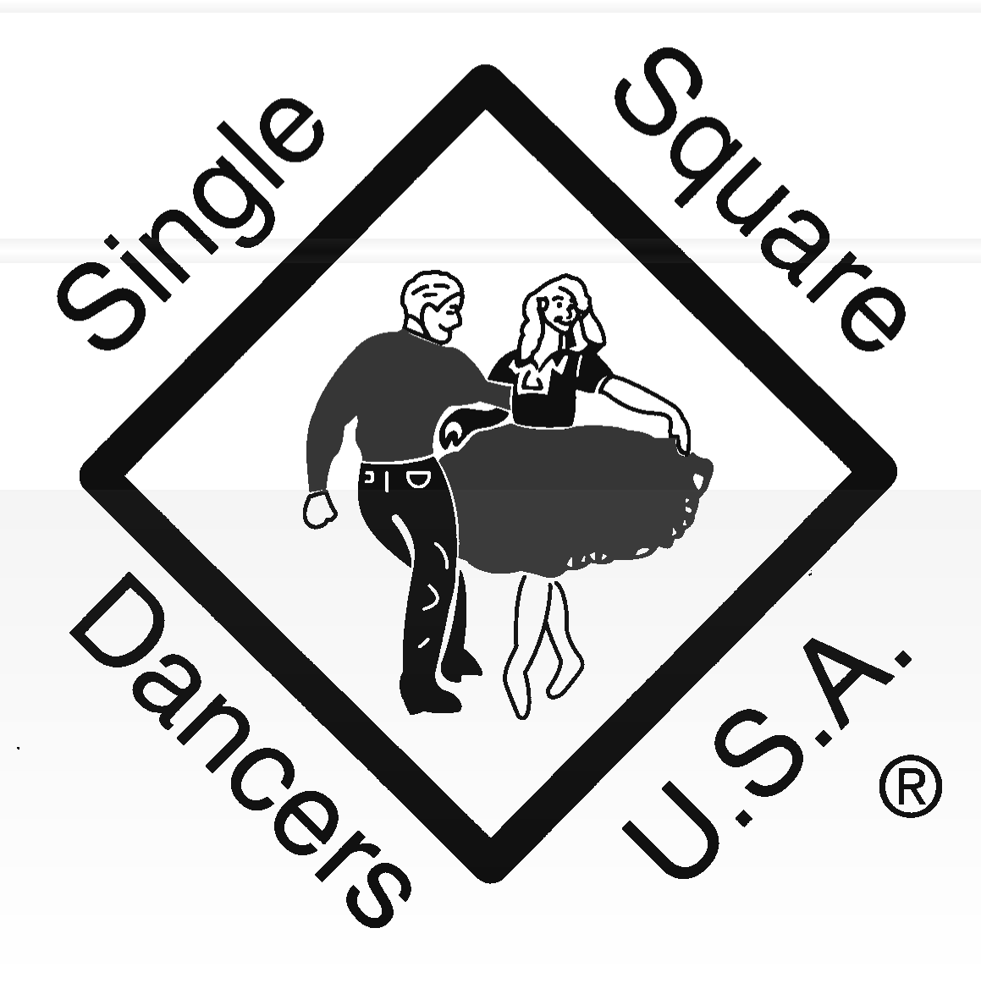

DANCE-A-RAMA 2018 PROGRAM BOOK ADVERTISEMENT OPPORTUNITY

Dance-A-Rama 2018 is now selling advertising space in our program book which will be distributed to the hundreds of dancers who will attend this event in Indianapolis, IN from August 30 September 2, 2018. If you would like to invite dancers from all over the US, Canada, and other parts of the world to your club or event, or if you would like to advertise your product or service, this is a great way to do it at a very reasonable cost. Rates are listed on the order form below.

Even if you have no product or service to sell, there is an additional opportunity for you. If you would like to be listed in our program book as a “Supporter of Dance-A-Rama 2018”, you may contribute $1 or more. Those giving $1-4 will be listed at the “Bronze” level. Those giving $5-9 will be listed at the “Silver” level. Those giving $10 or more will be listed at the “Gold” level. Print your name clearly exactly as you want it listed.

Our program book will be printed in black and white. All submissions must be “camera ready.” Be sure to leave border space. Prefer electronic version of ad submission be sent to: hollandr@charter.net or squardanc@aol.com. Your ad payments must be received NO LATER THAN July 15, 2018.

Thank you for your support of Dance-A-Rama 2018.

Mail check, a copy of the ad, and order form to: Program Book Co-Chairs:
Ron Holland – 280 Walnut Grove Road, Lebanon, TN 3709-9110
John Cook – 346 East Center Street, Dunkirk, IN 47336

- - - - - - - - - - - - - - - - - - - - - - - - - - - - - - - - - - - - - - - - - - - - - - - - - - - - - - - - - - - - - - - - - - - - - - - - - - - - - - - - - - - - - - - - - - - - - - - - - - - - - - - - - -

Name

Address

City State Zip Code

Size Number
of Ads

Price Amount

Full Page (8” x 10-1/2”)
@ $50.00

Half page (8 x 5-1/4’)

@ $30.00

Quarter Page (4” x 5-1/4”)
@ $20.00

Eighth Page/Business Card (4” x 2-5/8’)
@ $10.00

Donation: (Name_ _)

TOTAL ___ ________

SSDUSA Club Membership Application
Name of club:
Number of members:
Contact Name:
Address:
City:
State: | Zip:
Phone: | Email:
Club Website:
Annual Dues: $10 per year for clubs up to 50 members (1 club delegate)
$15 per year for clubs with 51-100 members (2 club delegates)
$20 per year for clubs with 101 or more members (3 club delegates)
Delegate names:
Please check one: New membership ______ Renewal _____
If renewal and address has changed, please include old address.
Make checks payable to SSDUSA,
Mail to: Ailene Picheco, 345 Hula Circle , Merritt Island, FL 32952 ; 321-652-0680

AILENE PICHECO
345 Hula Circle,
Merritt Island, FL 32952

The Official Newsletter of Single Square Dancers, USA
First Class Mail
Address Correction Requested

SSDUSA Individual Membership Application
Name:
Address:
City:
State: | Zip:
Phone: | Email:
Annual Dues $6.00 | 9 x 9 SSDUSA Embroidered Patch $12
Membership Badge $5.00
Make checks payable to SSDUSA, Mail to: Ailene Picheco, 345 Hula Circle , Merritt Island, FL;
32952, 321-652-0680

