

Official Newsletter of Single Square Dancers, U.S.A. - Joe B. Ellis, Founder May 2019 Issue

49th Dance-A-Rama
Hyatt Regency Birmingham, The Wynfrey Hotel
August 30 – September 1, 2019
Hoover, AL

The 49th Dance-A- Rama is fast approaching us. I will be busy promoting at several State Conventions and special dances, which I will attend in the next four months. Some were mentioned in my Southeast Regional Director’s Report.

TOURS

One of the tours that we have set up on Thursday is the church/school pastored by Reverend Martin Luther King to which the National Guard escorted black children per the order of the President of the United States.

There is a lot to learn about segregation in the United States by attending this tour.

We have three hour tours on Friday and Saturday from which you will learn a lot about the Birmingham area. Of course, don’t forget the Mystery Tour on Sunday morning! Buy your ticket! Get on the bus! Only the driver knows!

CALLERS

The calling staff are all Silver Eagle Recording Artists and very experienced callers consisting of: Joe Goins (previous Dance-A-Rama caller), Tom Davis (previous Dance-A-Rama caller), Gene Aldridge (Yellow Rock Scholarship recipient), and Greg Hatmaker.

CUERS

Both, Robbie Carrington and Diane Martin-Hamilton, previous Line dance Cuers have advanced to Lines and Rounds!

DON’T forget the After Parties on Friday and Saturday nights!!!

Hotel rooms are available at the discount rate 3 days before the dance and 3 days after the dance.

All Line, Round, and Square Dancers are cordially invited and welcome!

Ron Holland – 49th DAR Chairman

SINGLE SQUARE DANCERS, USA OFFICERS

President
YellowRock Scholarship
VELMA DOYLE
velmadoyle@sbcglobal.net
3938 Crestfield Drive
Groveport, OH 43125
614-837-6974

Vice-President

VACANT

Secretary,
Intercom Editor
VIRGINIA M. FROMEL
vfromel51@comcast.net
6400 85th Place
New Carrollton, MD 20784
301-552-1576

Treasurer
SUSAN LEE
rflxsue@aol.com
819 Pleasantview Dr
Des Moines, IA 50315-2262
515-244-3247

Immediate Past President
ARTS
Promotions Director
ARBELL THOMPSON
arbellthompson@aol.com
19375 Cypress Ridge Ter, #406
Lansdowne, VA 20176
703-729-2109

Atlantic East:
HELEN JACOBSON
helen.jacobsonRN@gmail.com
10 Rickland Drive
Randolph, NJ 07869
201-230-4999

South East:
Archives, Historian,
Sergeant-at-Arms,
Nominations,
ByLaws/Parliamentarian,
Outfit & Merchandise
RON HOLLAND
hollandr@charter.net
280 Walnut Grove Road
Lebanon, TN 37090-9110
615-268-3797

South West:
JACQUE LESLIE
lesjac@yahoo.co
P.O. Box 382
Clarkdale, AZ 86324
928-634-7376

Message From Your President

N. Central East
FRED MOORE
velmadoyle@sbcglobal.net
3938 Crestfield Drive
Groveport, OH 43125
614-837-6974

North West:
DEBBIE PRICE
dprice5361@yahoo.com
2852 NE Liberty Avenue
Gresham, OR 97030
503-669-7114

North Cent. West:

VACANT

South Central:

VACANT

North East:
NANCY MIRABAL
nancylmirabal@yahoo.com
112 Falmouth Street
Rochester, NY 14615-1902
585-738-3431

49th DAR Coordinator
RON HOLLAND
hollandr@charter.net
280 Walnut Grove Road
Lebanon, TN 37090-9110
615-268-3797

Intercom Publisher
& Membership
AILENE PICHECO
apicheco@att.net
345 Hula Circle,
Merritt Island, FL 32952
321-652-0680

Room-mate Locator
LAURIE STEWARD
lkstewa@hotmail.com
6373 Falcon Way
Warsaw, MN 55087
507-685-4476

Web Master
CARL WEBSTER
carlwebster49@hotmail.com
48 Jordache Lane
Spencerport, NY 14559
928-600-7096

We are excited to be Alabama Bound! The 49th Dance-A-Rama is a board run festival, and we have been working hard getting things ready for your enjoyment. We are doing our part and now we need your support to make it a wonderful event. We need help getting the word out about our DAR. If you would like to help distribute flyers in your area, please contact Ron Holland or me, and we will send you flyers. Please register early and make your hotel reservations ASAP. Pre-registering helps us plan a better event and guarantees you a room at the dance venue. You can save $5.00 if you register before the price goes up on Aug 1. You need to book your room at the hotel by Aug 7 to be assured of the special pricing. To cut down on expenses, you may want to contact our roommate locator, Laurie Steward. The cost of the room is the same for one to four people. If for any reason you are not able to attend this year’s DAR, please at least renew your membership by completing a membership application and paying the $6.00 annual dues.
Be sure to sign up for one or more of our tours prior to the July 20th deadline. It would be a shame to come to the Birmingham area and not see the local sights. On Thursday, we will begin with a drive through Birmingham, as our tour guide points out sites of interest and tells us about the city’s history. Our tour of the Alabama Peanut Company sounds like fun. We will see a short film and take a walking tour with narrative through Sloss Furnaces National Historical Landmark, the oldest preserved industrial plant of its kind in the world. I especially look forward to our included lunch at the Irondale Cafe, the Original Whistlestop Café, which was made famous by Fannie Flagg in her book which was later made into the movie “Fried Green Tomatoes.” We will ride through Redmont Historic District, where we can enjoy the beautiful architecture and gardens. We are to be back at the hotel at 4:30 p.m., which will give us time to relax and get ready for the Trail-In Dance starting at 7:30 p.m.
Our Friday tour focuses on the civil rights movement and a lot of significant US history happened here. The must-see sites include Kelly Ingram Park, the Sixteenth Street Baptist Church and Birmingham’s Civil Rights Institute. Our Saturday tour spotlights Pepper Place Farmers Market where there will be fun activities like chef demos, book signings, and live music. This is followed by a visit to the Birmingham Museum of Art where we will enjoy a docent-guided tour that concentrates on the highlights of this outstanding museum. Our annual mystery dangle dance will be on Sunday morning; and, of course, the dance locations are a “mystery.”
If you attend the National Square Dance Convention in Atlanta, be sure to pick up one of the “ASK ME TO DANCE” ribbons that SSDUSA provides to be distributed at the conventions. Also, it would be good to look in your Program Book when you arrive to find the location of the solo programming which is to be from 10 a.m. to Noon on Thursday, Friday and Saturday. There will no longer be any solo after-parties at National Conventions due to policy changes.
We need your help to get the word out about the great dancing and all of the FUN we have at our Dance-A-Rama festivals. Just look at what we have to offer! We have a great line up of callers and cuers. There will be four different halls and none of the dancing will be on carpet. There will be square dancing programmed for you whether you dance Mainstream, Plus, DBD, A1 or A2. There will be rounds from levels II through V or VI. Also, there will be line dancing. All of the halls are on the same level; and if you stay at the host hotel, you will be close to the action.
All square and round dancers are welcome! See you in Alabama!

Velma Doyle, President

FRANK NORRIS YELLOWROCK SCHOLARSHIPS AVAILABLE

Single Square Dancers USA has a scholarship fund designed to help new callers and cuers with the expenses associated with getting started in their profession. It is open to any caller or cuer age 12 or over who has three years or less experience. (Youth ages 12 through 18 need to have parental consent.) Anyone interested in applying needs to submit a demo CD, along with an application, to Velma Doyle, Yellowrock Scholarship Chairperson, 3938 Crestfield Dr, Groveport, OH 43125. If you need a Yellowrock Scholarship application, download a copy from the SSDUSA Website: www.ssdusa.org, or contact me. The deadline for receipt of the completed packet is August 1. One or more scholarships will be awarded at DAR 2019 on Labor Day weekend.

If you know of beginner callers or cuers who might qualify for the scholarships, please let them know about SSDUSA’s Yellowrock Scholarships and encourage them to apply.

Velma Doyle
Yellowrock Scholarship Chairperson

TRESURER’S COMMENTS

From your Treasurer/2019 DAR Registrar:
Just a reminder as you are registering for this year's Dance-A-Rama, the cutoff date to register for any tours is July 20th. If we do not have our minimum number registered for a tour it will be cancelled, so don't wait to sign up.

Susan Lee, Treasurer

FROM THE ROOMMATE LOCATOR

Already into May. Have you made your hotel reservation yet? Looking forward to seeing all of you Labor Day Weekend. Roommate requests open June 1st. I won't start working them until the middle of July. Last year requests were really slow in coming in. Hope we can change that around this year. If you have email, that is very helpful to me. That way everything is in writing rather than a voice mail that accidentally gets deleted. Please do include a phone number as that can be helpful also. How many are you willing to have in your room, how many nights do you prefer to have a roommate, do you have a room reserved. These things are very helpful when deciding on a roommate.

See you Labor Day Weekend.

Laurie -- Lkstewa@hotmail.com, 507-685-4476 H or 507-210-6507 C

NEWS FROM NORTHEAST REGION

Hello all from chilly New York. Our weather has been crazy, one day 60's next freezing rain. Our club has been super busy, celebrating our 49th year of Cloverleaf squares and planning for our 50th next year. We are having a big celebration, have a hall with a luncheon and dance with our own Mike Callahan calling and Linda Loberti cuing. The hotel is just across the parking lot for everyone's convenience. Blast from the past. Right now we're trying to locate all past members, so we can notify them. In April, we had our annual tri-club dance. March 26th, many of us got together at the Maple Tree Inn for buckwheat pancakes and out to dance with the Dalton Gang. We have a future road trip to Batavia Silver Stars for their Dingus dance to retrieve our banner and maybe steal theirs. Dingus day in Poland is celebrated with red and white so we all will be decked out. April 28th, we are graduating 11 new dancers including 2 young people whose enthusiasm has spurred us all to new heights. DOR is in May celebrating all new dancers from all clubs. In July we again welcome the Gottas for a fun evening. Don't forget all of you, WE WILL be Alabama in September for DAR hosted be SSDUSA. Great tours and lots of dancing means a fun time for all. See you all in a square!

Nancy L. Mirabal, Regional Director
NEWS FROM NORTH CENTRAL EAST REGION

I am looking forward to attending the 59th Ohio Dance Convention which is May 3-5, 2019 at the Bertram Inn & Conference Center, 600 North Aurora Rd, Aurora, OH 44202. The theme is “Dance to the Moon and Back.” On Thursday evening, May 2, there is a choice of two different Trail In dances at the Bertram that have separate sponsors. There will be many callers, cuers and dance leaders and all levels of dancing at the convention itself. A Solo Meet and Greet is scheduled from 3 to 5 p.m. on Friday. For more information, go to www.59odc.com.

There are quite a few opportunities for solo friendly dancing coming up in Central Ohio. On Sunday, May 19, the Friendly Ties Fiesta Dinner Dance will be from 5:30 to 8:30 p.m., preceded with a potluck meal starting at 4:30 p.m. Location: Pickerington Senior Center, 150 Herford Drive, Pickerington, OH. Pam Courts & Jason Raleigh will be calling and yodeling. Chuck Berry will be on rounds. Bucks & Does Singles and Orbiting Squares both dance all summer, with Bucks & Does dancing on fourth Fridays and Orbiting on first and third Fridays. Both clubs dance at the Gahanna Community Congregational Church, 470 Havens Corners Rd, Gahanna, OH. Time: 8 to 10:30 p.m. (Early rounds at 7:30 PM). On Sunday, July 14, from 2 to 6 p.m., Orbiting Squares and Buckeye A2’s will be co-sponsoring the Americana Jamboree special dance at the Gahanna Church, featuring callers Sam Dunn and Dave Stuthard and cuer Phyllis Burdette. Advance: 2 to 3 p.m.; Early Rounds: 3 to 3:30 p.m.; and Plus with Rounds 3:30 to 6 p.m. On Sunday, July 21, the Little Brown Jug Singles’ Summer Luau Dance will be held at Eagles Lodge # 376, 127 E William St, Delaware from 2 to 5 p.m. Caller: Jack Pladdys. Cuer: Elaine Winthrow. On Sunday, August 25, Maple Leaf Squares is featuring National Caller Tony Oxendine at a special dance at the Granville High School Commons, 248 New Burg Street, Granville, OH from 3 to 6 p.m. For more information about these dances, go to www.columbussquaredance.com..

When you are traveling and want to find a club where you can dance, I recommend that you go to www.wheresthedance.com to locate dances in the areas where you will be. Fill in the zip code of the town where you are going. Click on Search for Events, then click on the name of the club. There normally is a contact phone number that you can call to confirm that the dance is still on and check to see if they welcome solo dancers.

I am excited that the 49th Dance-A-Rama festival this Labor Day weekend will be in the Birmingham, AL area. I have not visited or danced in Alabama, and I look forward to dancing and going on the tours. I hope to see you there in a square!

Fred Moore, Regional Director

NEWS FROM SOUTH EAST REGION

Recently I attended the Fultondale Alabama Spring Jubilee ON March 28/29. There were about 100 attendees, and I knew about 30 of them. I handed out 300 flyers about the DAR and received a good response.

The Georgia State Singles Association is having their 37th Anniversary Dance on May 17 and 18, 2019. Their caller is Darryl McMillan from Decatur, Alabama. The curer is Miriam Merriwether from Ft. Walton Beach, Fl. They welcome all singles, pairs and groups to their weekend called "Getting My Happy Dance On!" in Macon, Georgia.

I will be attending the Denim Dusters on April 27th here in Nashville. Robbie Carrington is scheduled to be the cuer. She is also on board for the DAR in Hoover, Alabama.

I anticipate attending several dances in my region in the next 2-3 months to include Virginia State on May 16-18, the National Convention in Atlanta the last week of June, South Carolina Convention July 24-25, Tennesse Convention in Gatlinburg on August 1–4, and of course I will be attending the Dance-A-Rama in Hoover, Alabama on Labor Day weekend.

Ron Holland, Regional Director

NEWS FROM ATLANTIC EAST REGION

Are you familiar with the Cherry Ridge Campsite and Lodging in Honesdale PA? Cherry Ridge is a wonderful family-owned campsite dedicated to square dancing. Each weekend between May 1 and October 1, Cherry Ridge holds a square dance weekend that focuses on a specific dance program. They host fabulous callers!! Meals are available at the Country Kitchen, or you can choose to prepare your own. They use a computer generated square rotation system, so that everyone dances. Lodging is comfortable and reasonable. They have cabins, RV and tent sites. For schedule and information: www.cherryridgecampsites.com, or call (570) 488 – 6654.

MD: The 50th Star Spangled Banner Festival “Lands on the Moon” on July 18-20 at the Delta Baltimore Hunt Valley Club in Hunt Valley Maryland. Callers include: Tom Miller (PA), Bill Harrison (MD), Todd Fellegy ( CT), Jack Pladdys (OH), and Don Moger (QC). Cuers are: Wayne and Barbara Blackford (FL), Curt and Tammy Worlock (FL), and John and Karen Herr (CO). Information and flier are at marylandsquaredancing.com.

NJ: The Northern New Jersey Square Dance Association and their member clubs are pleased to announce that this spring they are graduating 90 Mainstream grads and 48 Plus grads. In addition, some experienced dancers repeated the lessons in order become more comfortable in other positions!

NJ: Hix & Chix/Western Wheelers (a mostly solo club) will sponsor a Special Summer Dance with Howard and Donna Williamson on Thursday, July 11 at the VFW at 6 Veterans Place, Elmwood Park, NJ 07407. For more info, call
973-427-2889.

NJ/NY: The Times Squares is the only square dance club right in NYC. On Friday, June 28, they will be commemorating the 50th anniversary of the anti-gay violence at the Stonewall Pub in NYC. Square Up at Stonewall will be held at John Jay College in NYC. On Saturday, June 30, they will square dance down the avenue as part of the Gay Pride March. Information is on timessquares.nyc.

NC: The North Carolina 30th State Square Dance Convention will be August 17 – 18. At the North Raleigh Hilton in Raleigh, NC. They have a HUGE list of callers and cuers. Info at North Carolina Folk, Round, and Square Dance Federation.

Helen Jacobson, Regional Director

HELP WANTED!!!!!!!!!!!!!!!
NORTH CENTRAL WEST AND SOUTH CENTRAL REGIONAL DIRECTORS
A cry goes out – WE NEED YOU!! WE WANT YOU TO JOIN US!! Why don’t you call us and volunteer for one of the following vacancies. We have three regions that need representatives. SSDUSA has divided up the U.S. into regions and have assigned representatives to provide a voice for singles throughout the U.S. We currently have three Regions that have no representation. Won’t you consider representing your regional area if you live in any of the states in the following Regions? The Regions that have no representation currently on our Board are:
North Central West Region – consists of the following states: Iowa, Minnesota, Nebraska, North Dakota, South Dakota, Wisconsin, Upper Michigan and Canada
South Central Region – consists of the following states: Arkansas, Kansas, Louisiana, Missouri, Oklahoma and Texas
Wouldn’t you like to volunteer for one of these positions? Please contact one of the following to find out more information:
Velma Doyle, President 614-837-6974 email: velmadoyle@sbcglobal.net.

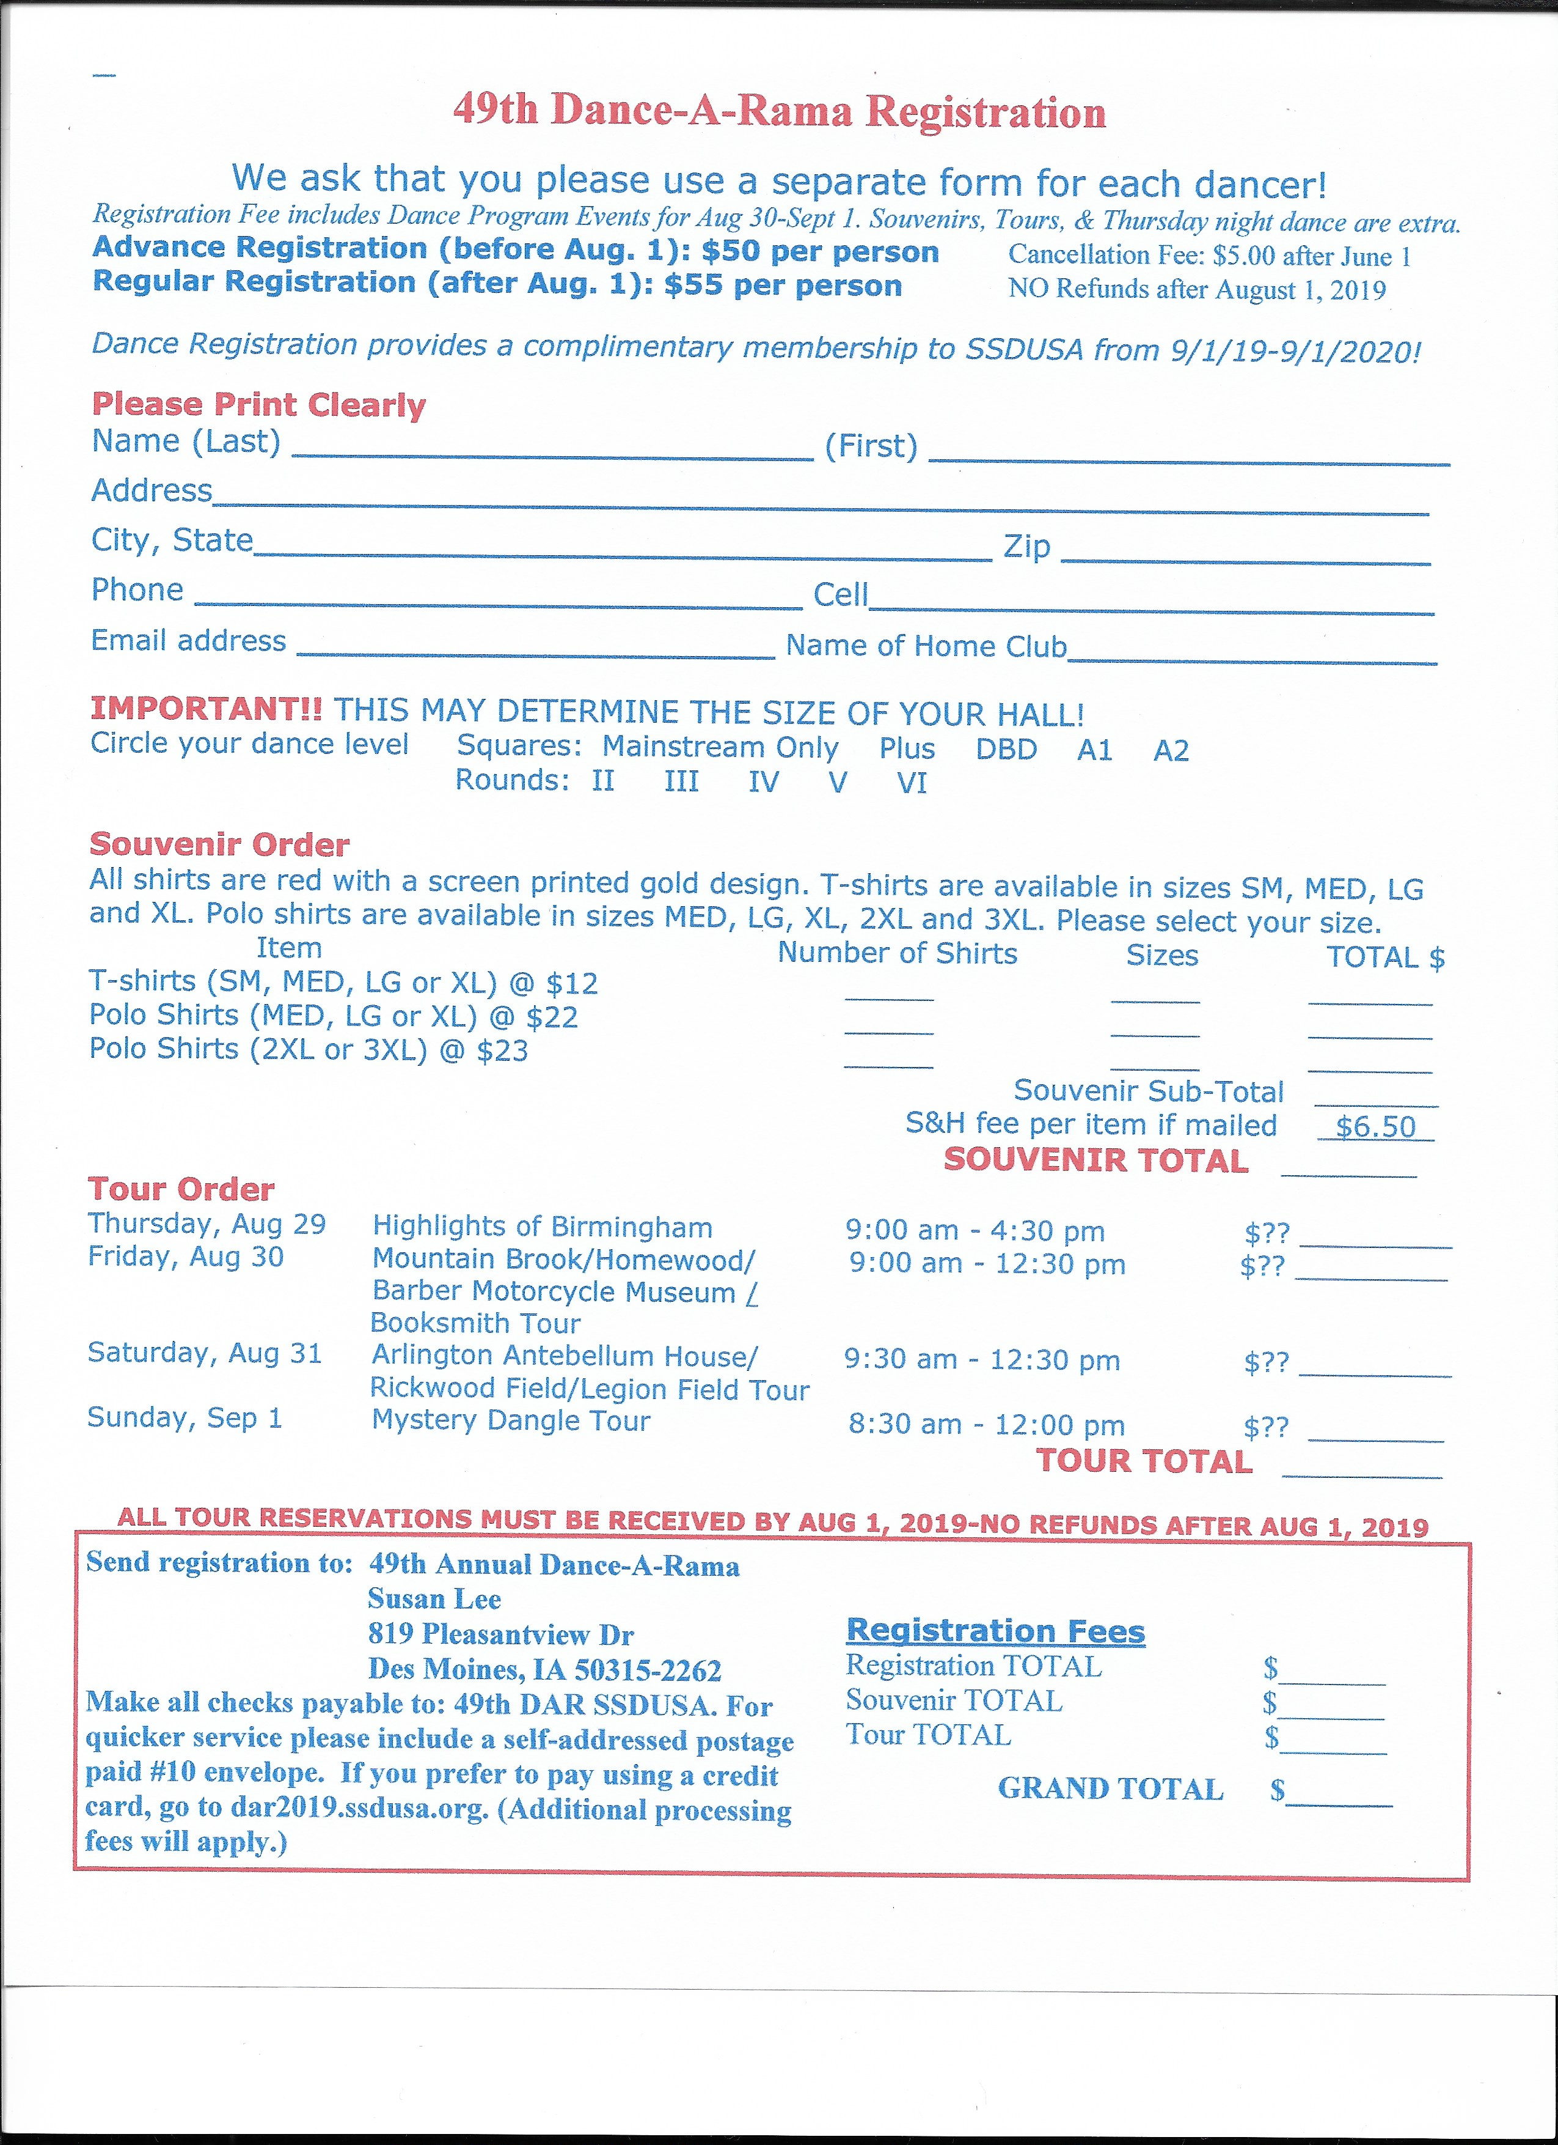

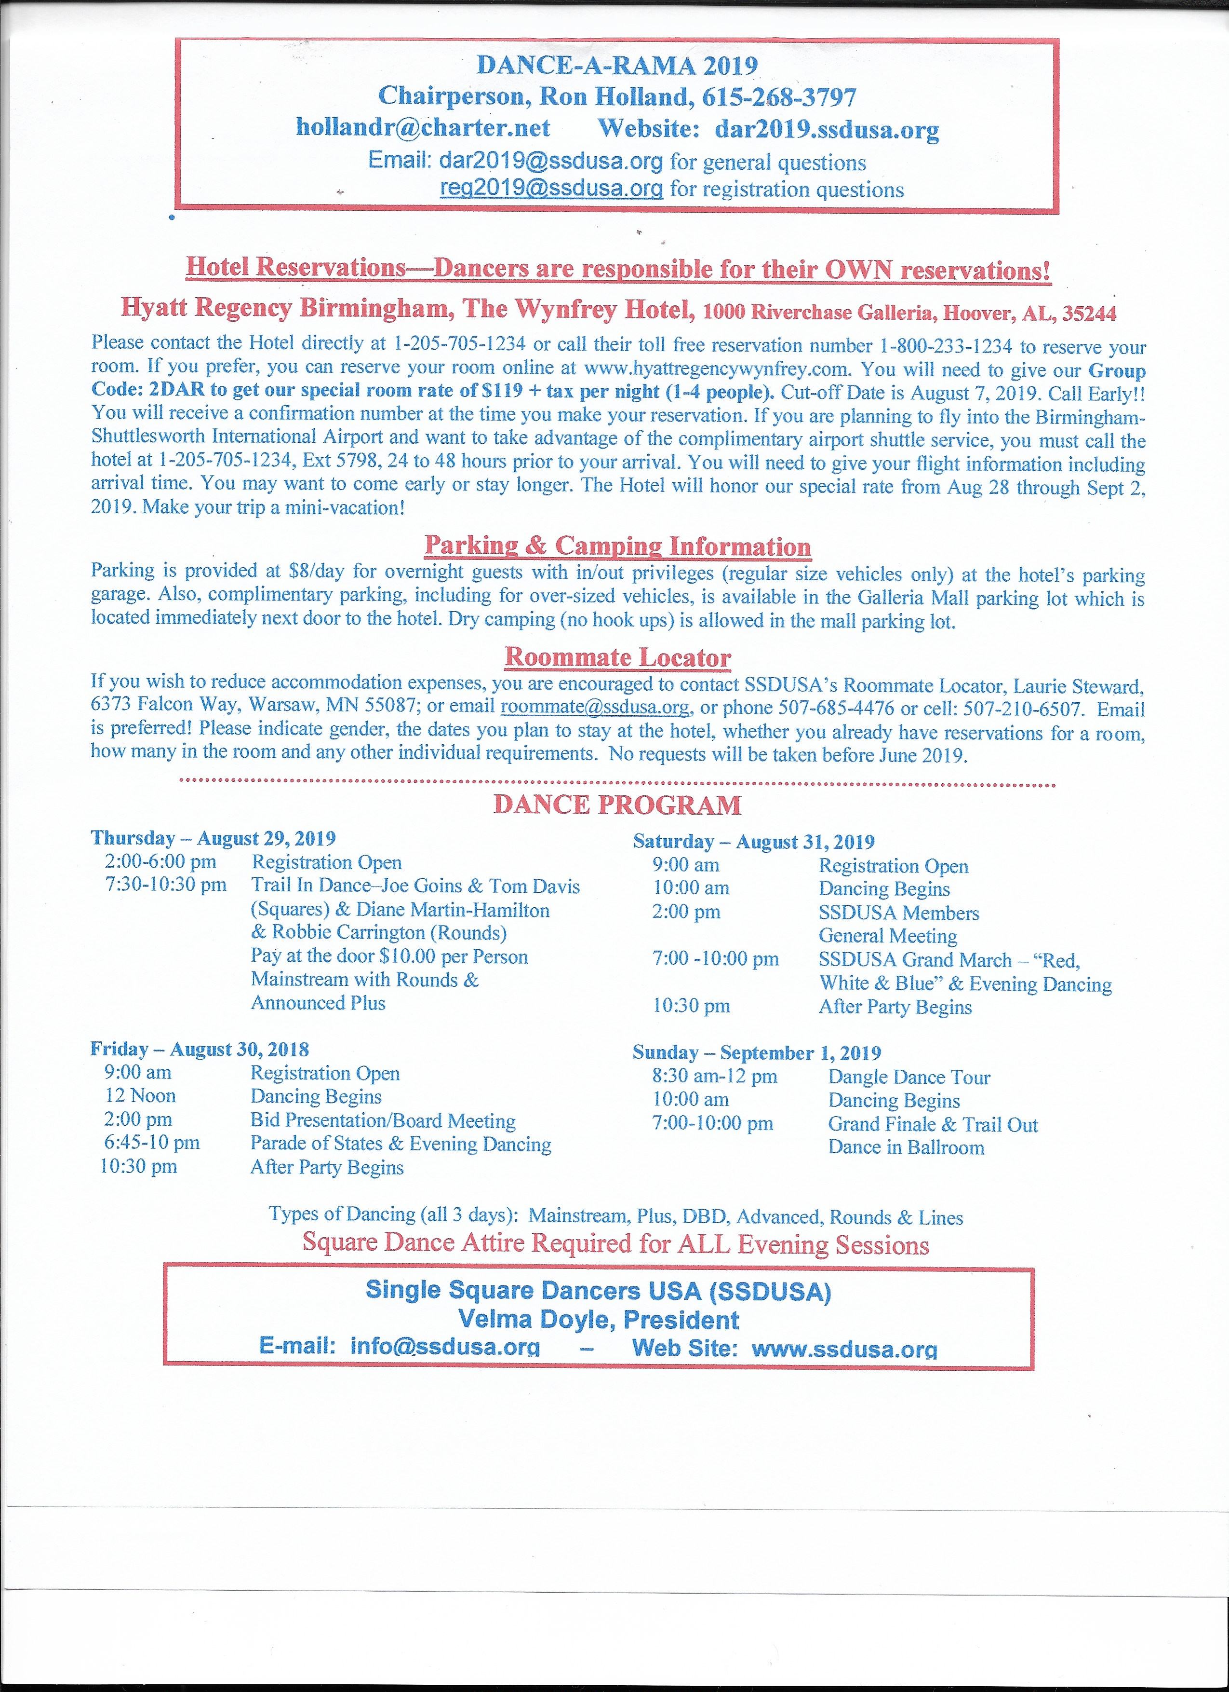
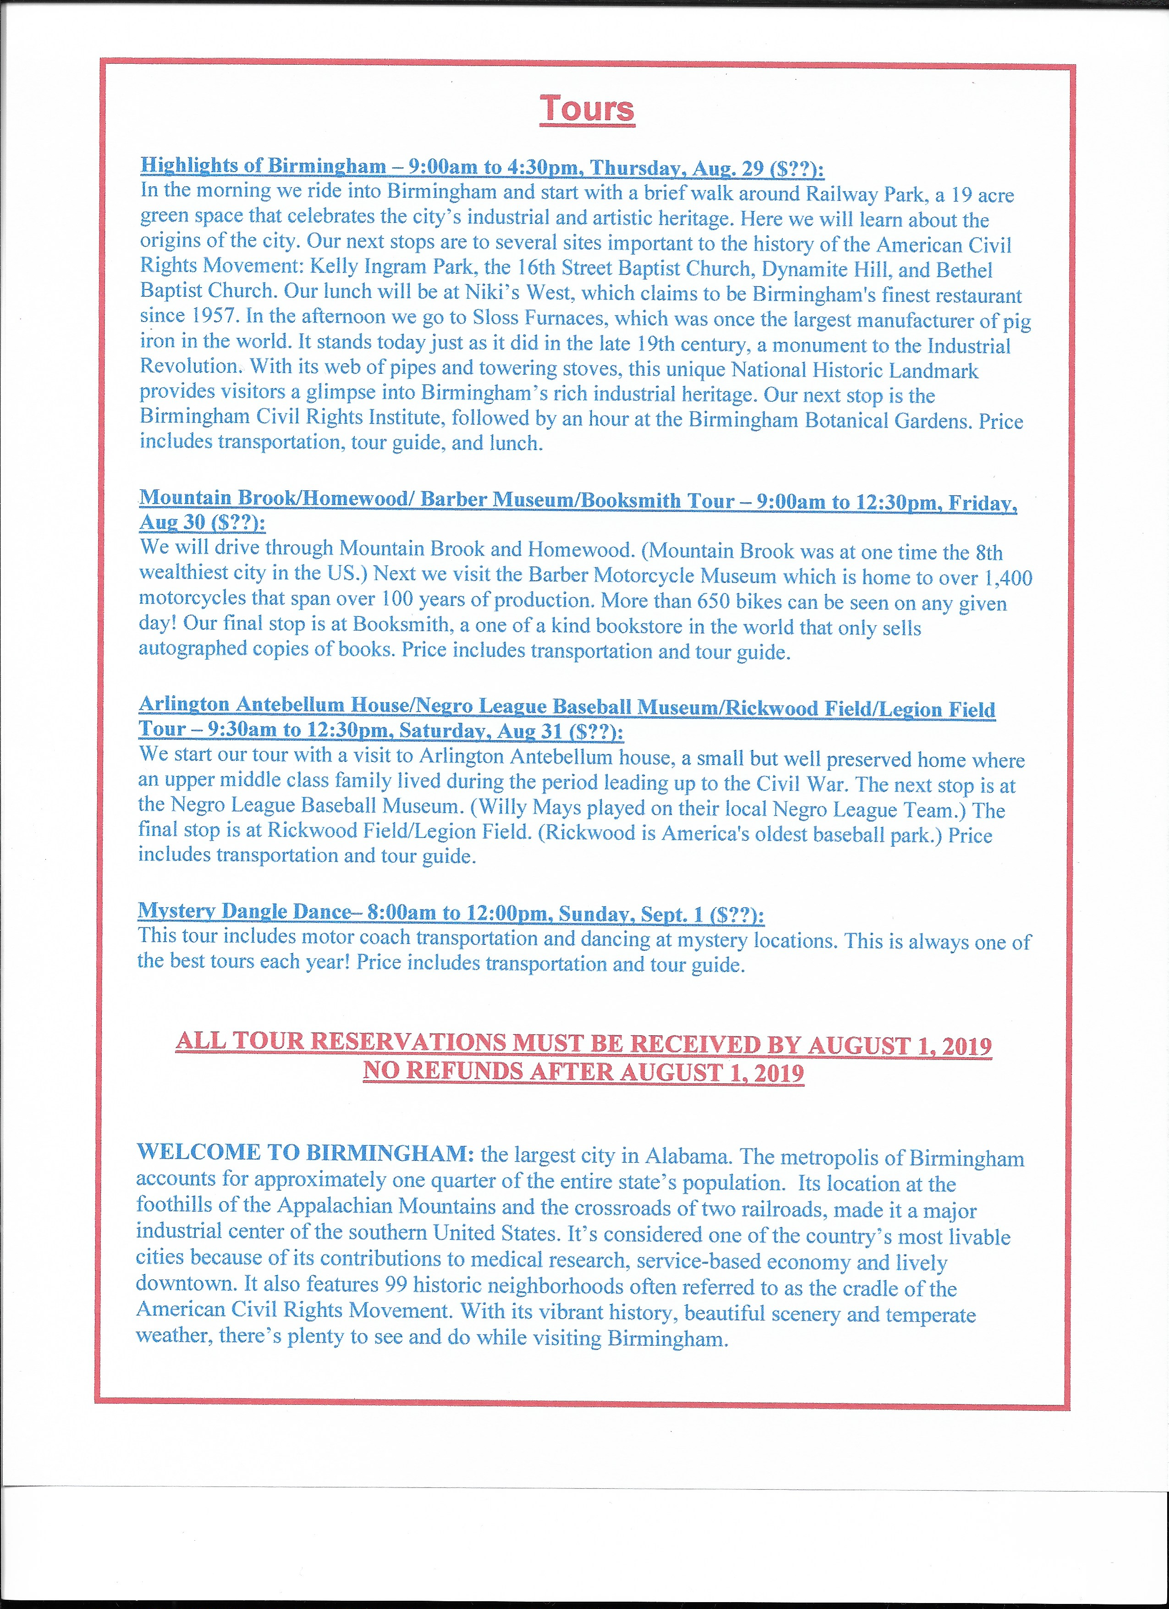

SSDUSA Club Membership Application
Name of club:
Number of members:
Contact Name:
Address:
City:
State: | Zip:
Phone: | Email:
Club Website:
Annual Dues: $10 per year for clubs up to 50 members (1 club delegate)
$15 per year for clubs with 51-100 members (2 club delegates)
$20 per year for clubs with 101 or more members (3 club delegates)
Delegate names:
Please check one: New membership ______ Renewal _____
If renewal and address has changed, please include old address.
Make checks payable to SSDUSA,
Mail to: Ailene Picheco, 345 Hula Circle , Merritt Island, FL 32952 ; 321-652-0680

AILENE PICHECO
345 Hula Circle,
Merritt Island, FL 32952

The Official Newsletter of Single Square Dancers, USA
First Class Mail
Address Correction Requested

SSDUSA Individual Membership Application
Name:
Address:
City:
State: | Zip:
Phone: | Email:
Annual Dues $6.00 | 9 x 9 SSDUSA Embroidered Patch $12
Membership Badge $5.00
Make checks payable to SSDUSA, Mail to: Ailene Picheco, 345 Hula Circle , Merritt Island, FL;
32952, 321-652-0680

